**Shipyard Golf League**

**Rules and Guidelines**



**2023 Season**

League Officers

League Administration

League Play

Handicaps

Playoffs

App A - SGL Rules

App A - Local Rules

App B – HC

Current Year Revisions from SGL22-Rules-v1:

Officers: Revised EC positions Suggestions: Added

Rule 3: Revised, entirety Rule 6: Revised, $240

Rule 8: Revised, 2 point difference Rule 17: Revised, Pace of Play

Winter Rules: Clarified Year Round Sand Trap Rule: Revised

Root Rule: Added Local Rule: Added Deer Run

Hole-Side Drop: Revised

**Shipbuilder Golf League**

**Rules and Guidelines**

League Officers

Executive Committee (EC)

President/Treasurer Ryan Lorson 380-3881

Vice President / Rules Brandon Kelly 534-0592

Vice President / Operations Kevin Roscoe 864-4173

Handicap Administrator Bruce Herring 688-8159 Fax: 534-4299

Handicap Committee (HC)

Member Ron Hand 688-6026

Member Robert Holley 688-8952

Member Tom Newman 688-8870

Suggestions

For suggestions, please email us at sglsuggestions@gmail.com

League Administration

1. All Shipbuilder Golf League (SGL) activities that occur at work involving the use of company resources and property must be approved in advance by your Manager and comply with all applicable policies and procedures. Such activities must not interfere with normal operations of the company and must take place during lunch or before/after work; unless, approved in advance by your immediate supervisor to flex the time used to address SGL activities.
2. The League officers, team captains or their representatives will make league rules (only one vote per team). The President will incorporate all new rule changes after the Spring Captain’s meeting. The Rules enclosed will govern the league play for the currentseason. Once the season has started, the Rules will not be changed.
3. New SGL members will be current shipyard employees, contractors and customers working for or with the shipyard.  Returning members and teams are those who played in the prior season, are all eligible.  Non-returning members are those who have played in the SGL, but didn’t play in the prior season.   Those who have 20 scores on the books, are all eligible.  Those with less than 20 scores must submit a request to the EC.  The books are kept for 5 years after a member’s last season.
4. There will be up to 12 players on a team roster and the rosters should be provided to the Handicap Administrator by the date specified on the *SGL Calendar*. Players cannot be added to a roster after the date specified on the *SGL Calendar* without the approval of the Executive Committee. The team roster may not exceed 12 players. Before a player can be added to a team, a player must be dropped once the 12-player limit has been reached. Any odd situation that arises shall be taken to the Executive Committee. Changes must be made 24 hours in advance of the next match (The day before you play).
5. 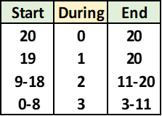A player must play from 0 to 3 matches during the current season in order to qualify for the playoffs, according to the table below (relief has been granted odd situations). The number of matches required “during” the season, depends on how many they have played prior to the “start” of the season. If a player quits the company after the season has started, they are still eligible for the remainder of the season and the playoffs, provided have qualified per the table, and prior to quitting the company.
6. Each team will be charged **$240** for league dues. The money will be applied to the purchase of trophies (1st & 2nd Place for League Champions and Runner-up, Plaques for 1st place team in each division), payment of the Handicap Administrator, partial greens fees for the Championship Match (6 tee times) and subsidizing of the Members’ Tournament. Team captains are to send a check or money order to the Treasurer by the date specified on the *SGL Calendar*. Teams not paid in full by this date will forfeit all scheduled matches after this date until league dues are paid (received by the Treasurer).
7. Schedule of tee times, dates, courses and matches shall be made by the President and given to each team captain. The Treasurer is to pay Handicap Administrator (the lesser of $500 or $2 per SGL player) after final handicaps are provided.

League Play

1. Matches will consist of a 6-on-6 9-hole competition, Monday through Thursday after work. The winner of a match will be based on the team with the lowest team net score. The team net score consists of six (6) net scores, one score for each player. A player’s net score consists of a player’s gross score minus his course handicap, not to exceed 8 net points (max net score). Players receive gross points for every stroke over par with a triple bogey limit per hole played (Triple Bogey or worse: 3 points, Double Bogey: 2 points, Bogey: 1 points, Par: 0 points, Birdie: -1 points, etc…).

The scorekeeper (Rule 9) shall record the gross points scored for each player for each hole played. If a player does not finish a hole, scores a triple bogey or worse, then that player will be given 3 gross points for that hole. For teams with only five (5) players the sixth player, a “No Show”, will be awarded 2 net points more than the max net score (10 net points for the match). Teams with four (4) or fewer players will forfeit the match, and the scores for that match will not count towards league play. The Handicap Administrator will provide the player’s course handicap prior to a match.

Equitable Stroke Control (ESC): If a player with a 4 or lower course handicap records a triple bogey or if a player with a 5-9 course handicap records a triple bogey on a par 5, then they will be awarded 1 ESC point for each occurrence. These points will be totaled for each player and reported on the official score sheet. The ESC points do not count when determining the team net score. Do not include ESC points when the max net score is invoked.

1. The home team per, the schedule provided by the President, or the weekly update (WU) provided by the Handicap Administrator, will have the honors on the first hole and will be the official scorekeeper for the match (if there is a conflict, let the President know, and if necessary, make a decision at the course). The scorekeeper will email (or fax) a copy of the official score sheet to the Handicap Administrator, President, and the Captain of the opponent after a match (please send it the next day or sooner).
2. Men, seniors and women will compete from the tees listed in *SGL Courses*. Primary and secondary make-up match courses are also listed in *SGL Courses* (see Rule 14 for make-up matches). A senior is any man, 60 years of age and older who declares to the Handicap Administrator 2 days prior to the publication of handicaps, his intention to play from the senior tees. Once a senior has declared he will not be able to switch back without EC approval.
3. USGA rules will apply unless modified by the League or by local rules (See Appendix A for a list of League and local rules). The Club Pro may be consulted about other local rules.
4. Each foursome in a match must complete a minimum of six (6) holes in order to be considered a league match. If players in a match were not able to complete 9 holes due to adverse playing conditions (rain, darkness, etc…), then their gross scores will be scaled to a 9-hole score. These scaled gross scores and a player’s course handicap will be used to determine a winner of the match and will be used for handicap purposes. This may result in a decimal score. Record these scores at 1 decimal place and round up at 0.05.
5. Players that are not able to complete 6 holes during the match will be considered a No Show and assessed scores as required by Rule 8. A player may join a match in progress provided the following occurs: he is able to join a twosome or a threesome (a five-some (group of 5) will not be allowed unless specifically permitted by the course.), and he joins at the 4th tee or sooner (players may only join a match at a tee box). Players that arrive late or leave early and are not able to play the entire match will score a triple bogey on holes not played and will receive ESC points based on the holes they did play. The ESC points will be the difference between the player’s recorded gross score and his gross score on the holes he played scaled to a nine-hole score. Record the ESC points at 1 decimal place and round up at 0.05.
6. Matches that are rained out should have a makeup date scheduled within two weeks of the rain out date.  The home team captain is responsible to schedule a tee time.  Once scheduled and agreed to in writing (email), the matches are official.  If after 7 days the captains have not set a make-up date, then the president has the authority to set the date.  At the Presidents discretion (EC to review), rainouts not made up one week prior to league playoffs can be canceled (no points). Note:  Do not schedule a make-up match in front of normally scheduled league play.  When scheduling make-up matches, the preferred courses are listed in *SGL Courses.*
7. Teams should make every effort to have at least five players present at every match. More than two forfeits during the season will be viewed by the Executive Committee as excessive. The Executive Committee will review the circumstances behind the forfeits and possibly recommend suspension from the league.
8. It is hoped that all protests can be settled on the spot by the team captains or their representatives. If not, the captains will send a protest in writing within one (1) week to the President and the opposing team captain. The President will present the protest to the EC, and the EC will vote to approve or reject the protest.
9. Pace of Play: Members shall play the first 8 holes or fewer in 2 hours 15 minutes (135 minutes) or less, regardless of available daylight and tee time. After that, do not start a new hole and return the carts. The score keeper is to note the actual start time on the scorecard and calculates the maximum last hole tee off time. Pausing for weather does not count towards the 2 hours 15 minutes. Pace of play is enforceable by anyone in the group and can be invoked at any point after the 2 hour 15 minute mark.

Slow Play: Please notify the President and the opposing team captain in writing after experiencing excessive slow play during a match. The notifications will be used to encourage the offenders to speed up and will be the basis for future rule changes.

1. Emergency Powers: If a situation outside of normal SGL conditions occurs (not explicitly covered by the rules), the EC will interpret the rules. If the EC is not available due to time constraints, then the President will have the authority of the EC and his decision will be final. The EC will review the President’s decisions after the fact to consider future rule changes.

Handicaps

1. Course handicaps provided by the Handicap Administrator will be used for all League play. All scores during the regular season will be used to calculate a player’s handicap.
2. A Handicap Committee will be established to ensure the integrity handicaps issued by the Handicap Administrator. The committee has the responsibility of making certain that a player’s SGL handicap index reflects his potential scoring ability per Section 8 of the Rules of Golf. The committee will recommend changes to a player’s handicap to the Executive Committee, who will vote to either accept or reject the recommendation. HC membership shall be per Appendix rule B.3.
3. The SGL handicaps will be calculated based on the USGA Handicap Formula. The oldest and worst scores will be dropped from handicap calculations according the number of matches played. One additional score will be dropped after the following numbers of matches have been played: 2, 3, 4, 6, 8, 10, 12, 14, 16 and 18. Once a player has played 20 matches, only the most recent 20 scores are used. Based on the USGA handicap differential (HD) formula below (the worst scores are the higher HDs):

Handicap Differential = 0.96 x (Adjusted Gross Score - SGL Course Rating) x 113 / SGL Slope Rating

Where: Adjusted Gross Score = Par + Gross Points – ESC Points.

Note: The course and slope ratings are listed in *SGL Courses*.

The remaining better scores (lower HDs) will be averaged to calculate a handicap index (HI). The HI will be scaled to a course handicap (CH) by the ratio of the slope rating over 113 + the course rating - par. The CH will be calculated based on the Course and Slope rating of the tees played (i.e., men’s, women’s or seniors’). For men 70 years of age and older the CH will be based on men’s tees. The HI will be limited to 27.0 when calculating a CH, and the CH will be limited to 18 for 9 holes and 36 for 18 holes.

1. Players returning to the League who did not play in the prior season are considered rejoining players (not new players) and the Handicap Committee will determine their handicap based on past performance. Note: Historical data for the prior 5 seasons will be maintained.
2. New players will report to the SGL how well they can play via a New Player Form. The SGL will then assign the player a handicap based on this information. Team captains will be responsible for the accuracy of the new player’s claim. If the HC recommends that a new player’s handicap should be adjusted, and the EC agrees, then the new player’s handicap would be adjusted retroactively to the beginning of the season (the playoffs are considered the beginning of a new season). This may change the outcome of the matches where this player’s handicap was changed. If the HC determines that a new player intentionally misrepresented his playing ability, the HC will report this to the EC, and they will vote to remove or not to remove this player from the SGL.

Playoffs

1. Eight (8) teams from each division will qualify for the playoffs. The playoffs will proceed based on a seeded 16-team field in accordance with the playoff bracket below. The teams will be seeded in accordance to final standings and with the A league team seeded above the corresponding B league team in odd numbered years. The higher seed in each division will be determined by: 1.) Total points with wins worth 2 points and ties worth 1 point. 2.) Record head to head. 3.) Total net points scored head to head. 4.) Total net points differential during the season. 5) A coin flip.

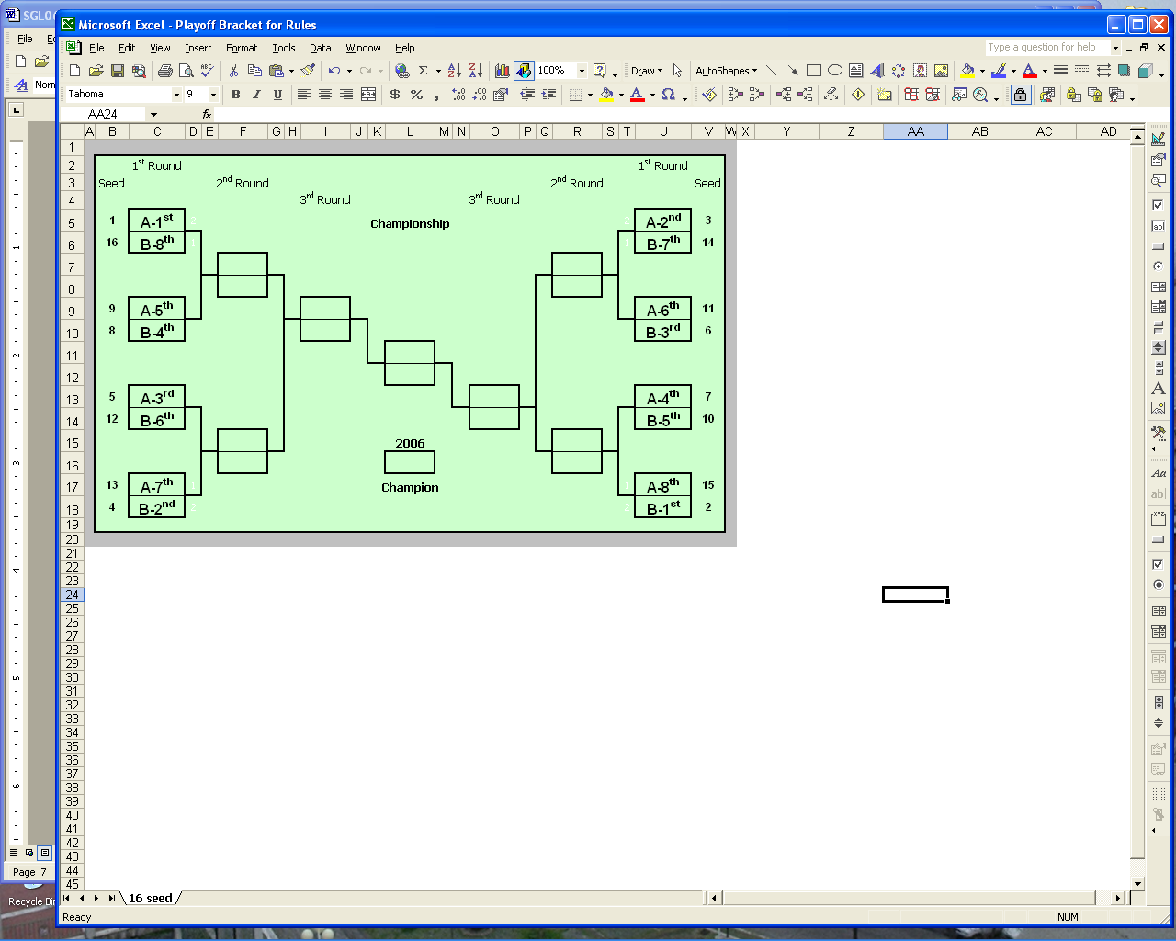

1. All playoff scores will count double (entered twice) towards a player’s handicap. A player’s handicap will be recalculated prior to the next playoff round. In addition to those playing in the championship match, members who placed in the money in the Member’s Tournament, will have their scores counted double towards their next handicap.
2. The first three rounds will consist of two 6-on-6 9-holes matches, with every player on the team playing once during the week. The winner will be determined by the totaling best 11 net scores. The No Show rule applies for teams with 11 or fewer players.

A team is allowed three substitutes for eligible players each round. A player may be a substitute only once during the playoffs without EC approval. The substitute is an eligible player, a member of the playoff team, and they will play twice in one round (i.e., against the same opponent). The substitutes will be selected by their team captain from the players who played in the first half of the match.

In the playoffs the higher seed will be the home team. The highest seed will select the course from the regular season courses, and days (Mon-Wed or Tue-Thurs) for their match. The second highest seed will select the days and course from the remaining choices, and so on for the other seeds. Once scheduled, the daily matches may not be canceled due to bad weather before 2 pm without the President’s approval.

1. If a tie occurs in the first three rounds of the playoffs, use the total net points that were scored on the 2 lowest handicap holes of competition to break the tie. The total net points consist of all gross points scored on the 2 lowest handicap holes minus 2/9ths of the total handicap. A No Show contributes 1.1 points (10/9) per hole to the team net. If the match remains tied after applying this procedure, add the scores for the 3rd lowest handicap hole to this procedure minus 3/9ths of the team handicap to break the tie. Continue adding holes to the procedure to break the tie. If the match remains tied after the procedure is applied to the entire round, then flip a coin to determine the winner (higher ranking seed will choose).
2. The Championship match will be an 18-hole match with the best 10 net scores used to determine the champion. The No Show rule applies for teams with 9 or fewer players. If a tie occurs during the championship match, the tiebreaker will be a 6 on 6, 9-hole match during the week in accordance with normal league play.

**Appendix A**

## SGL and Local Rules

**SGL Rules**

**Gimme Putts:** May be taken at the player’s option if your opponent concedes the putt.

**Winter Rules (All Year Long)**:

*A player may roll the ball with the head of his club if his ball is located on closely mown grass on the hole that he is playing. When rolling the ball, the player may not locate his ball closer to the green or roll it further than 1-yard from the original location.*

*Penalty for breach of rule: 1 stroke.*

**Rangefinders and GPS:** Allowed in league play. No restrictions.

**Lift, Clean and Place:** When the course conditions for a match are such that the team captains or their representatives decide that relief will be granted for play “through the green”, then the following defines the procedure for League play:

*A player will mark the original location of the ball, lift it, may clean it and will place it within 6 inches of the original location, but not nearer to the hole or the putting green. A player may lift the ball once and after the ball has been placed, it is in play.*

*Penalty for breach of rule: 1 stroke.*

Note: “Through the green” includes everything on the course except the tee and green of the hole being played and the Penalty Areas (water and bunkers). The team representatives should agree to “lift, clean and place” in the bunkers (see Sand Traps) but should not agree to do so in a body of water.

**“Out-of-Bounds”:** *Net Penalty – 2 strokes*. If you hit a ball **OB**, then you have the option of hitting your next shot from the original location (e.g., tee box) with a one stroke penalty **or** taking the distance, dropping the ball in accordance USGA with a two stroke penalty. See OB Option on next page.

**“Lost Ball”:** *Net Penalty – 1 stroke*. If you lose a ball into the woods/water/rough, but not OB, then go to the point where the ball entered the woods/water/rough and drop it in accordance with USGA with a one stroke penalty.

**Unplayable Lie:** *Net Penalty – 1 stroke.* If the ball is located in the woods, it may be dropped using USGA rules for OB and Lost Ball.

**Caddies:** *Penalty – triple bogey per hole used, disqualification if used on 4 or more holes (see rule 7).* The use of caddies is prohibited, unless permission is specifically granted by the opponents.

**Sand Traps:** At the player’s option, the player may smooth the sand in way of their ball with no penalty. The intent to put the ball back from where you picked it up. Since you are smoothing (raking) that location, mark it to the best of your ability. With your opponent’s concurrence, place the ball and continue play.

**Root Rule:** At the player’s option and without penalty, the player may place the ball, at the nearest point of relief, to clear any tree roots that may impede a player’s swing. The player should try to keep it within 2 club lengths, if possible, while trying to maintain the original line-to-pin. This rule is intend for tree roots only and not trees. If a tree is impeding a player’s swing, the player would have the option to play it as it lies or declare it an Unplayable Lie.

**Competition Course:**

Regular season only: The front 9 is consider the competition course, and the back 9 a practice course. If the course sends a match off the back 9, there is no penalty for playing the competition course prior to the match. This SGL Rule is not applicable to the playoffs.

**Practicing** on the competition course:

First offence is a 2-stroke penalty. Second offence is DQ. Examples: Without permission from the opponents, practicing a putt on the green before finishing the hole is an offense. Playing a round on the competition course is a DQ.

**2019 New USGA Rule**

**IX. O.B. option**

Courses may implement a Local Rule (not for competition) that offers an alternative to the stroke-and-distance penalty for lost balls* or shots hit out-of-bounds. A player may drop a ball anywhere between where the original ball was believed to come to rest (or went out-of-bounds) and just into the edge of the fairway, but no nearer the hole. The golfer takes a two-stroke penalty* and plays on instead of returning to the tee. This way, the Local Rule mimics your score if you had played a decent provisional ball.

* SGL uses a 1 stroke penalty for lost ball

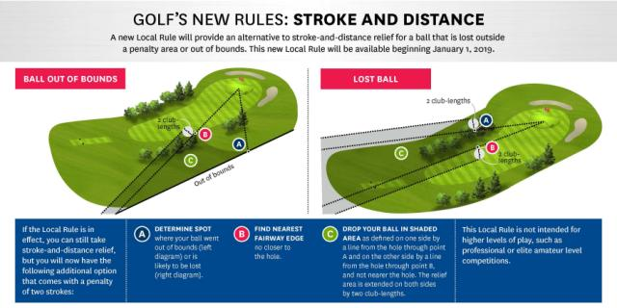

*Courtesy of the USGA and R&A*

**Course Specific Local Rules:**

**Old Hampton:**

1. Penalty Area drop zone for hole #4 is located approximately 100 yards from the green on the left side of the fairway, and on the same side of the water as the green. Any tee shot that enters the penalty area may be dropped in the drop zone.
2. Penalty Area drop zone for hole #6 is located approximately 20 yards in front of the green on the right side of the fairway. Any shot that was advanced beyond the drop zone and enters the Penalty Area may be dropped in the drop zone. (Note: there is a black stake that delineates the Yellow Penalty Area from the Red Penalty Area.)
3. Old railroad tracks between holes 1, 2, 8 and 9 are considered part of the course.
4. The fences on holes 3 and 5 are course boundaries. The ball is played where it lands with no free drop. If the fence is in the way of the backswing, it may be played as an unplayable lie, ball may be dropped two club lengths away from the fence no closer to the hole, one stroke penalty. If the ball goes through the fence on either hole 3 or 5, the ball is out of bounds. Proceed with USGA Rules or OB Option.

**Sleepy Hole:**

1. Penalty Area drop zone for hole #6 is located approximately 200 yards from the green on the left side of the fairway. Any shot that enters the Penalty Area may be dropped in this drop zone.

**Woods and Links:**

1. Power lines: If a ball strikes the power lines, the ball **must** be replayed from the original location. There is no penalty.

**Cypress Creek:**

1. Red tees are designated drop areas on all par 3s.

**Deer Run**

1. The chain link fences on the golf course are course boundaries (OB).

**Hole side-drop:**

For any stroke on any golf course that is required to clear a Penalty Area (PA), except the tee shot on hole #9 at CC, and it does not clear the PA, then the player can proceed as follows:

* Place the ball in the agreed to drop area on the hole side of the PA, and within 2 club lengths of the PA while maintaining the line of flight into the PA
* The drop area should have an unobstructed line of flight to the pin, and if not, move drop area towards the center of the fairway.
* The drop should not be on the green or collar

**Appendix B**

## HANDICAP COMMITTEE RESPONSIBILITIES AND POLICIES

**1. Purpose:**  The purpose of the SGL Handicap Committee is to ensure the integrity of SGL handicaps.

**2. Intent**: The intent of the SGL Rules and the Handicap Committee in particular is to ensure that all member teams and players may compete fairly over the course of a season. All players should have the desire and incentive to compete to the best of their ability on every hole, in every match.

**3. Membership:** The SGL Handicap Committee shall consist of members in good standing, and are appointed by the President.

**4. Handicap Index:** A Handicap Index (handicap) is a measurement of a player's ***potential scoring*** ability on a course of standard difficulty. Potential scoring ability is measured by a player's ***best scores***, and is expressed as a number taken to one decimal place. These scores are identified by calculating the handicap differential for each score. The USGA Handicap Index is calculated by taking 96 percent of the average of the best handicap differentials, and applying Section 10-3 of the USGA Rules for golfers with two or more eligible tournament scores. The SGL shall compute SGL Handicaps by a similar process, adjusted as provided in the SGL Rules.

**5. Handicap Indices and Scoring Records:** Current scoring records of all players in the club from the most recent update shall be available to all members. The Handicap Administrator is responsible for players' records and keeping Handicap Indices (handicaps) up-to-date. Handicaps will be updated weekly and distributed to all team captains. Team Captains have the responsibility to further promulgate playing records and handicap calculations to their team members as they deem necessary.

**6. Duties and Responsibilities:** The duties and responsibilities of the SGL Handicap Committee shall be in general accord with Section 8 of USGA Rules pertaining to Handicap Committee functions at established golf clubs, and as specified below.

**6.1.** The Handicap Committee shall review the accuracy of handicap calculations. If any errors exist, a corrected SGL Handicap Index Listing shall be issued as soon as possible after a scoring error is noted. Errors in handicap calculations that affect the results of team match play shall be rectified.

**6.2.** Team Captains shall ensure that all acceptable scores from their team members are entered correctly and if an error correction is required, shall notify the Handicap Committee and Handicap Administrator within 2 days of publication of a handicap listing update.

**6.3.** The Handicap Committee shall ensure that SGL Handicap computations and adjustments are in accordance with the SGL Handicap Formula.

**6.4.** The Handicap Committee shall reduce or increase Handicap Indexes of any player whose handicap does not reflect his **potential scoring ability**. A reduction in a player’s handicap because of a dramatic and consistent improvement in playing ability shall not be automatically construed as a deliberate manipulation.

**6.4.1.** The following information documents the different types of new players (as defined by the SGL rules) and the action performed for each.

**Mercy Player**

Definition: A player or players that have overestimated his or her playing ability on the new player form (NPF).

A player becomes eligible for a mercy ruling after having played 2 matches and having a difference of 5 or more points (when comparing the NPF declaration and the best of their 2 scores).

OR

A player becomes eligible for a mercy ruling after having played 3 or more matches and having a difference of 3.5 or more points (when comparing the NPF declaration and the average of their best 2 scores). And so on for 4 matches and a difference of 3.0 and 5 matches and a difference of 2.5.

Action: When a player qualifies for the “Mercy” rule as stated above, the NPF declaration is dropped and the player’s handicap is then recalculated based on their scores. THERE IS NO RETROACTIVE REVIEW OF MATCHES PLAYED OR ADJUSTMENTS IN THE OUTCOME OF MATCHES FOR MERCY RULING PLAYERS.

**Humble Player**

Definition: A player or players that have underestimated his or her playing ability on the new player form (NPF).

A “humble” player becomes categorized as a “humble player” when the difference between their declaration on the NPF and their actual scores are greater than or equal to 3 (i.e. they’re averaging 3 or more points better than what was declared on the NPF).

Action: The HC begins tracking the new players immediately. After a player has played 3 matches (or if the season is coming to an end the scores in place are used) and the their scores are still greater than or equal to 3 points above their NPF declaration, the HC makes adjustments to the humble players handicap so that their scores reflect their NPF. After the adjustment, the matches played by the humble player are reviewed and adjusted to the new handicap. This may result in the change of a match result.

**Accurate Player**

Definition: A player or players that have accurately estimated his or her playing ability on the new player form (NPF) and has proven such by not falling into the Mercy or Humble Player category.

Action: No action is required by the HC. This player’s handicap will be controlled by the handicap formula and the player’s scores.

**6.5.** The Handicap Committee shall establish guidelines for establishing appropriate handicaps for new and returning players. The current SGL policy for new players is to establish a handicap for each player that represents his/her mid-season form/potential scoring ability. This is accomplished by the player and captain filling out the SGL New Player Form (NPF). This will place the new players on the same level as the returning players that have well-established handicaps.

**6.6.** The Handicap Committee shall publish its rationale and decisions affecting the handicaps of all SGL members or identifiable classes of SGL members (e.g., high handicap players as a group, new members, returning members, members rejoining after a one-year absence, etc.).

**6.7.** SGL Handicap index adjustments shall be completed and published with the first issue of the season’s SGL handicap listings by the Handicap Administrator. Thereafter, any individual changes will be announced via letter to the affected player and team captain.

**6.8.** Any team captain or league member (through his/her Team captain) in good standing may request review of a player’s handicap by submitting a Handicap Review Request form to any member of the Executive Committee. The Executive Committee member shall then refer the request to the Handicap Committee for investigation. The Handicap Committee shall conduct a fair, thorough, and private investigation into the request. If the review request involves submittal of suspect scores, the investigation process shall provide an opportunity for the player to explain the circumstances which resulted in submittal of suspect scores.

**6.9.** A finding that a deliberate manipulation of one or more scores shall result in appropriate redress, which may include any or all of the following:

1. adjustment of a player’s handicap index,
2. altering the results of team match play if such handicap correction would have affected the outcome of one or more matches, and
3. banning of the player from league play for the balance of the season.

Redress shall be applied only with the unanimous agreement of the Executive Committee and the Handicap Committee.

**6.10.** The Handicap Committee shall document for its files and promulgate the results of any investigation of alleged handicap manipulation to: the SGL Executive Committee, the person alleging manipulation of scores, and the accused. However, the comments of individuals contacted during a review process will be disclosed only to Handicap Committee members.

**6.11.** The Handicap Committee shall prepare and recommend changes to the SGL rules as they relate to handicapping procedures, for consideration by the Executive Committee, and by league captains at the annual Captain’s meeting.